A000-AM,C-Costa Rica-Nicoya-Axe Deity-Jade-900 CE

Costa Rica

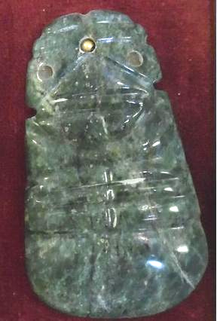

Case No.: 14

**Accession No.**

**Formal Label:** Costa Rica-Nicoya-Axe Deity-Jade-900 CE

**Display Description:**

This jade axe deity amulet was believed to have an inhering spirit that could answer specific requests of the wearer. The earliest known worked jade in Costa Rica (in the form of an axe deity) was discovered at the site of La Regla on the Gulf of Nicoya. One of the most typical forms of Pre-Columbian Costa Rican lapidary work is the so-called axe-god, in which an animal, human being or a composite effigy surmounts a celt-like polished blade. Common in the Costa Rican lapidary corpus are axe-gods with at first glance appear to be avian effigies. They are in fact part of a zoo-anthropomorphic continuum, with many jades having relative degrees of "birdness" and "humanness." Outstanding among Costa Rican jades is the form long known in that country as the  dios-hacha, or axe deity. The term encompasses conveniently all the stylized figure pendants shaped as though they had been made from axes of petaloid celts. Costa Rican jadeite and greenstone artifacts can be divided into five basic categories: whole celt, half celt, quarter celt, and a general category of other forms. Most of the jade artifacts are pendants which appear to have been produced from raw material in the form of a celt. The most impressive jade pendant (found on the Lama Corral 3 site in Costa Rica) was a virtually three-dimensional quetzal (bird found in Mexico to Panama) effigy axe god. In Costa Rica, all artifacts made from green stone have traditionally been classified as jade.

**LC Classification:**

**Date or Time Horizon:**

**Geographical Area:**

**Map:**

**GPS coordinates:**

**Cultural Affiliation:**

**Media:**

**Dimensions:**

**Weight:**

**Condition:**

**Provenance:**

Highly polished, mottled piece that is perfect in every detail. Price: US $2,800.00

**Discussion:**

**References:**